

**CSE2007 : Database Management Systems**

**Name :** Gudi Varaprasad

**Reg. No. :** 19BCE7048

School of Computer Science and Engineering

**Lab Slot :** L45 + L46

**Date :** 18 – 02 – 2021

**Submitted to :** Ms. Dhanavanthini madam

**Lab Cycle-I (SQL)**

(Questions from 11 to 20)

**Creation of General Hardware Database (GHD), Insertion of data into GHD and writing and executing queries for the questions.**

**I. General Hardware Database:**

**SalesPerson(SalesPersonNumber, SalesPersonName, CommPercentage, YearHire, OfficeNumber)**

**Customer (CustomerNumber, CustomerName, SalesPersonNumber, HeadQuarterCity)**

**CustomerEmployee (CustomerNumber, EmployeeNumber, EmployeeName, Title)**

**Product (ProductNumber, ProductName, UnitPrice)**

**Sales (SalesPersonNumber, ProductNumber, Quantity)**

**Office (OfficeNumber, Telephone, Size)**

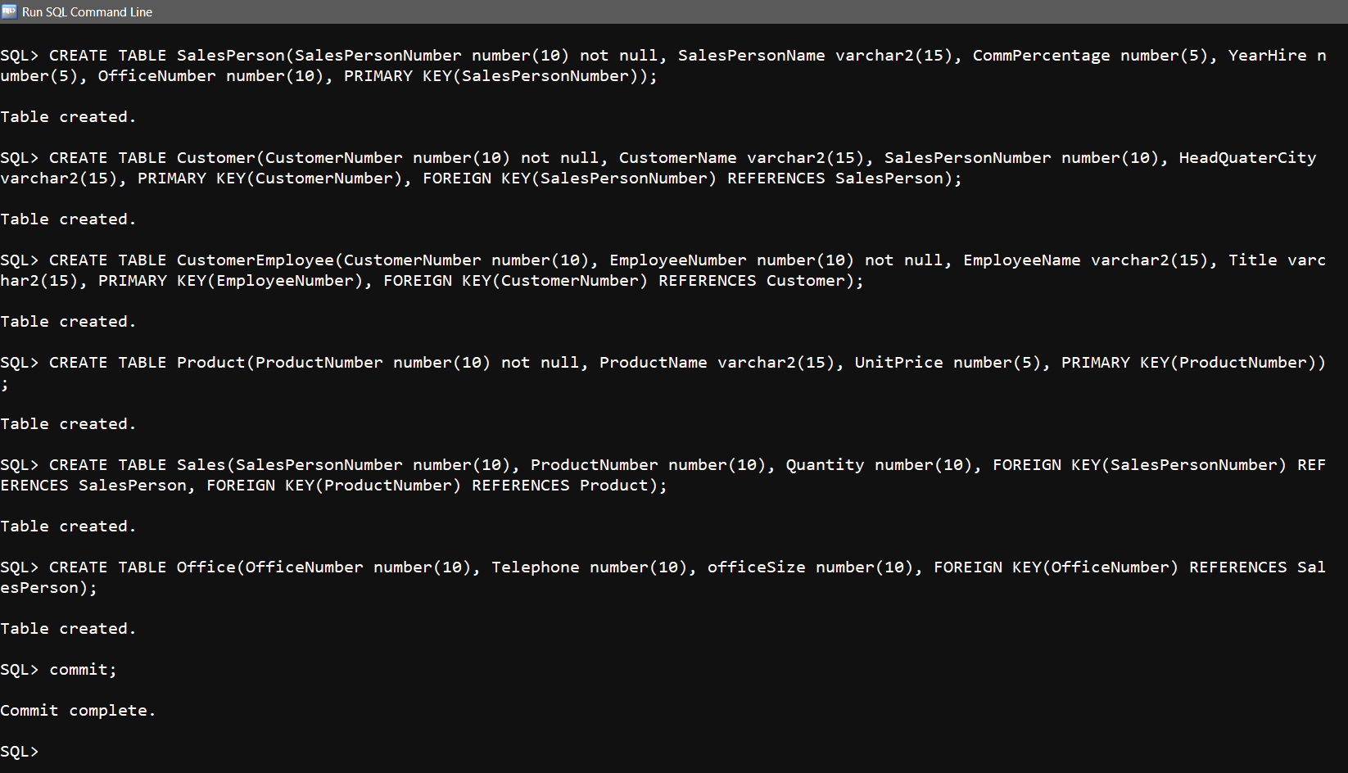

**Tables Description :**

> DESC SalesPerson;

> DESC Customer;

> DESC CustomerEmployee;

> DESC Product;

> DESC Sales;

> DESC Office;

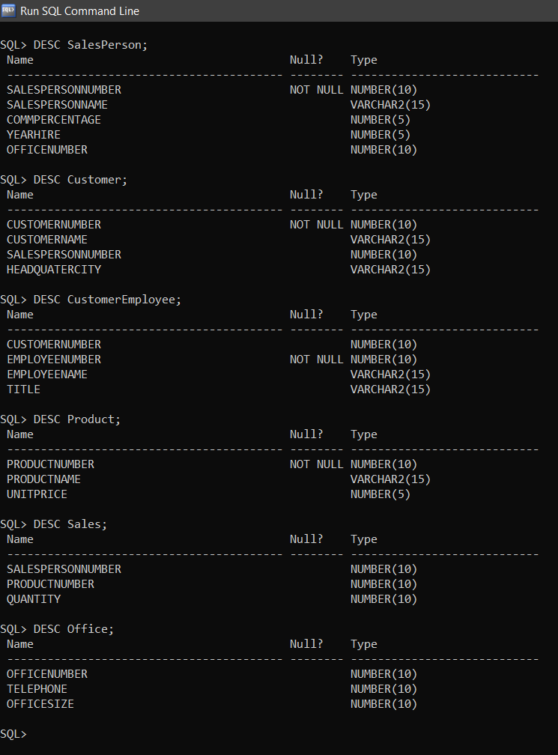

**Inserting Values :  
 SalesPerson Table**

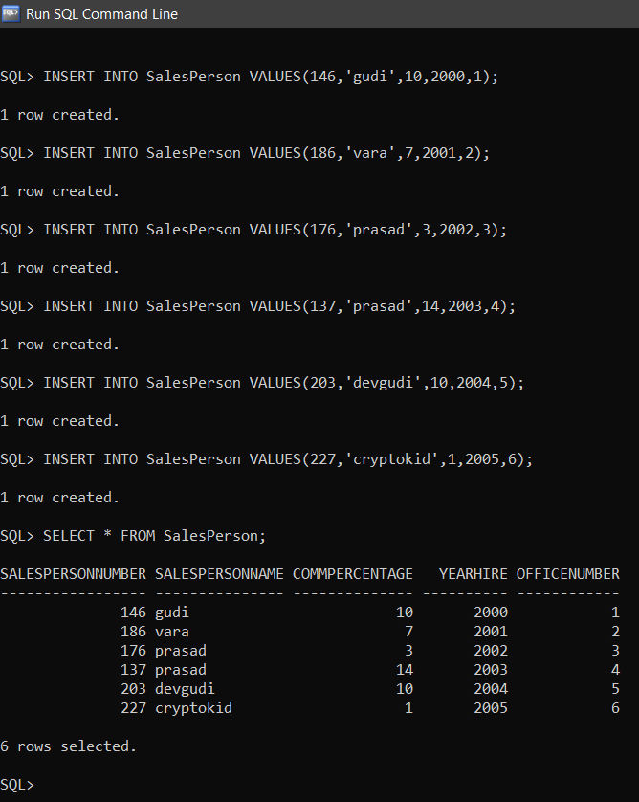

**Customer Table**

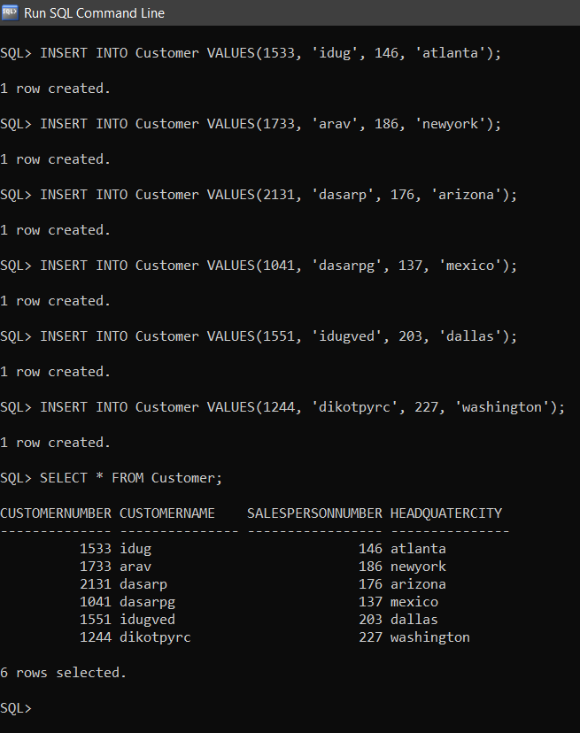

**CustomerEmployee**

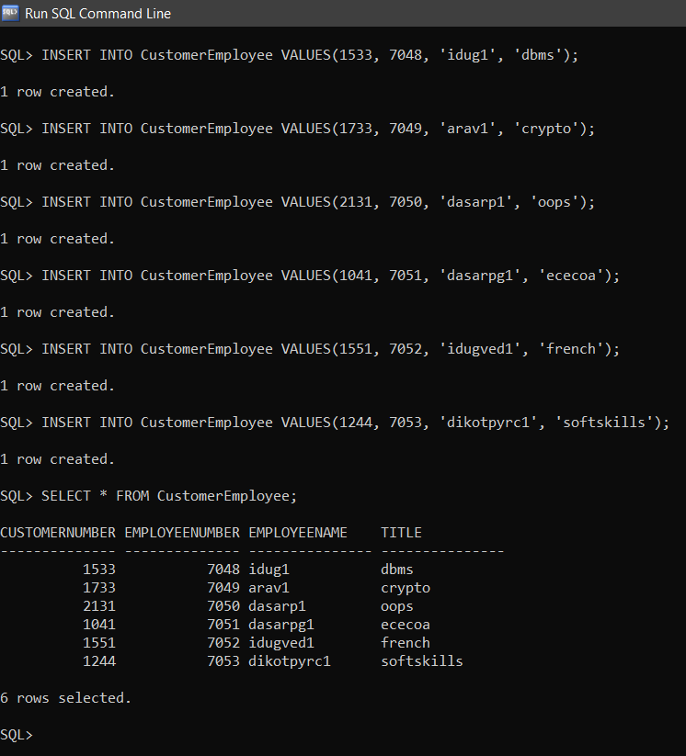

**Product Table**

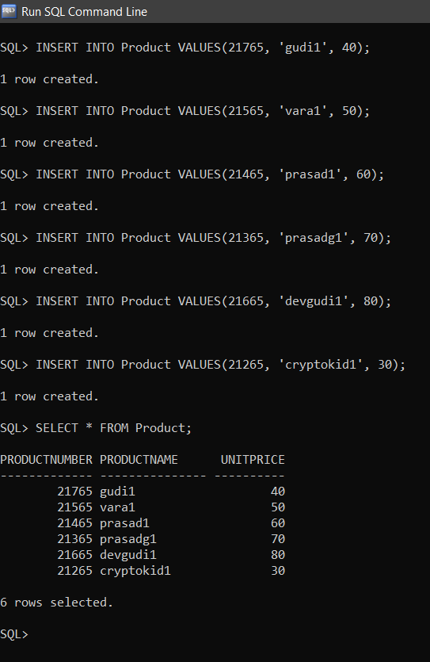

**Sales Table**

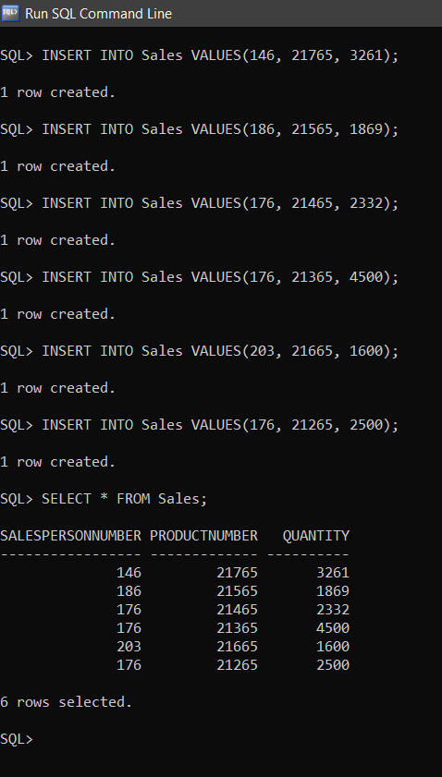

**Office Table**

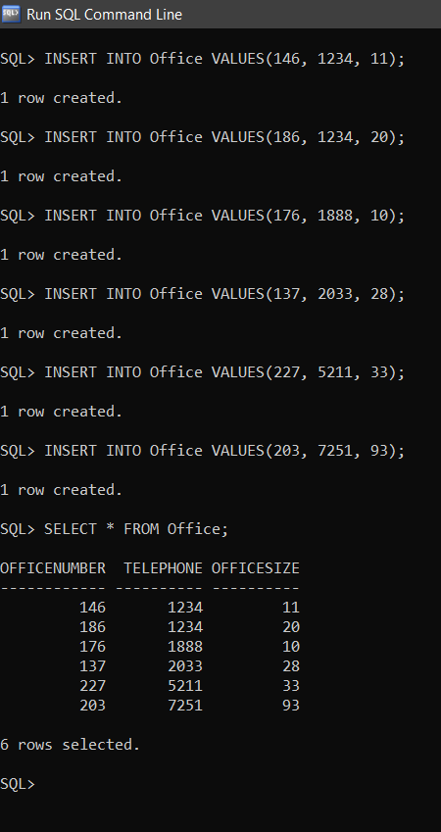

**Answer the following queries :**

**11. Find the average number of units of the different products that Salesperson 176 sold (i.e., the average of the quantity values in the first three records of the SALES table).**

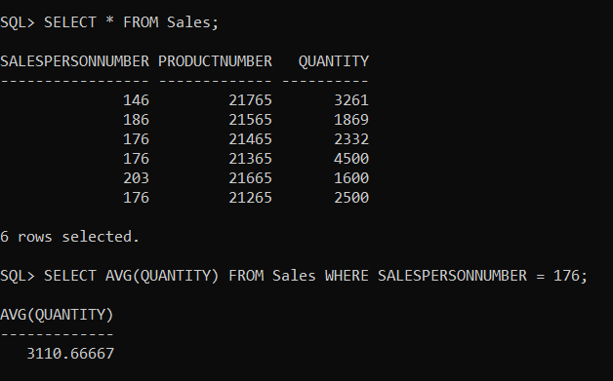

**12. What is the largest number of units of Product Number 21765 that any individual salesperson has sold?**

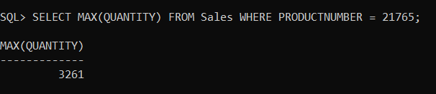

**13. How many salespersons have sold Product Number 21765?**

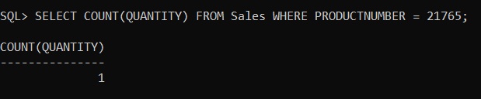

**14. Find the total number of units of all products sold by each salesperson.**

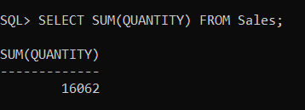

**15. Find the total number of units of all products sold by each salesperson whose salesperson number is at least 150.**

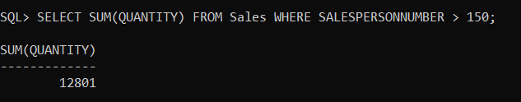

**16. Find the total number of units of all products sold by each salesperson whose salesperson number is at least 150.**



**17. Find the total number of units of all products sold by each salesperson whose salesperson number is at least 150. Include only salespersons whose total number of units sold is at least 5000.**

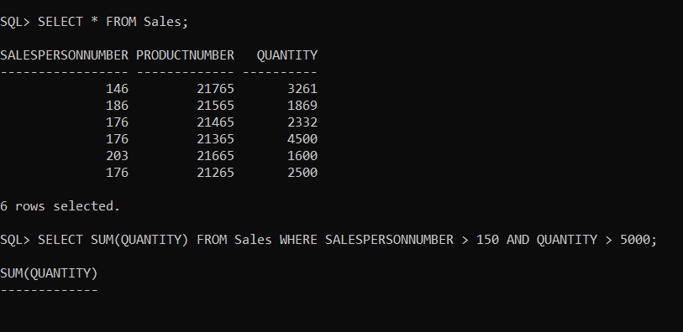

**18. Find the name of the salesperson responsible for Customer Number 1533.**

SELECT SALESPERSONNAME FROM SalesPerson, Customer WHERE SalesPerson. SALESPERSONNUMBER=Customer. SALESPERSONNUMBER AND CUSTOMERNUMBER =1533;

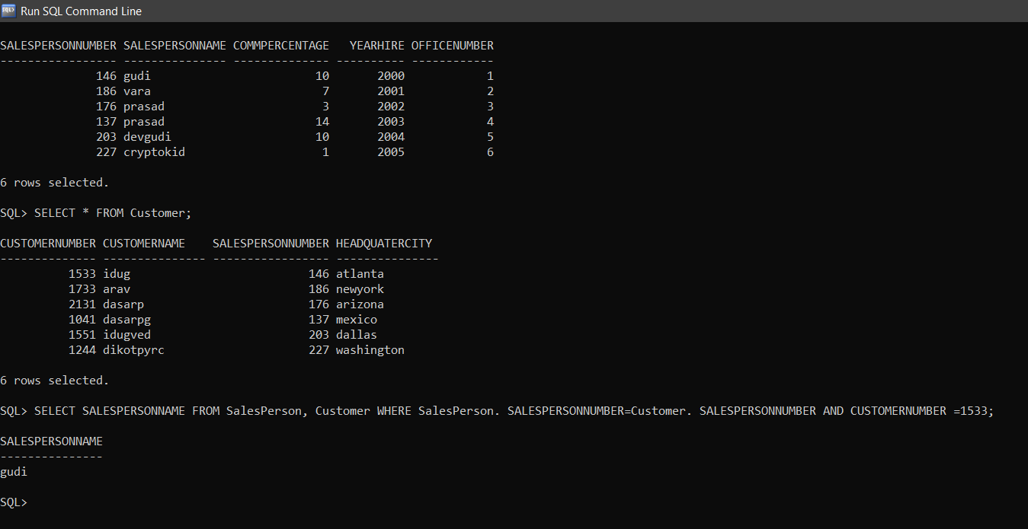

**19. List the names of the products of which salesperson ‘prasad’ has sold more than 2000 units.**

SELECT PRODUCTNAME FROM SalesPerson, Product, Sales WHERE SalesPerson.SALESPERSONNUMBER =SALES.SALESPERSONNUMBER AND SALES.PRODUCTNUMBER=PRODUCT.PRODUCTNUMBER AND SALESPERSONNAME=’prasad’ AND QUANTITY>2000;

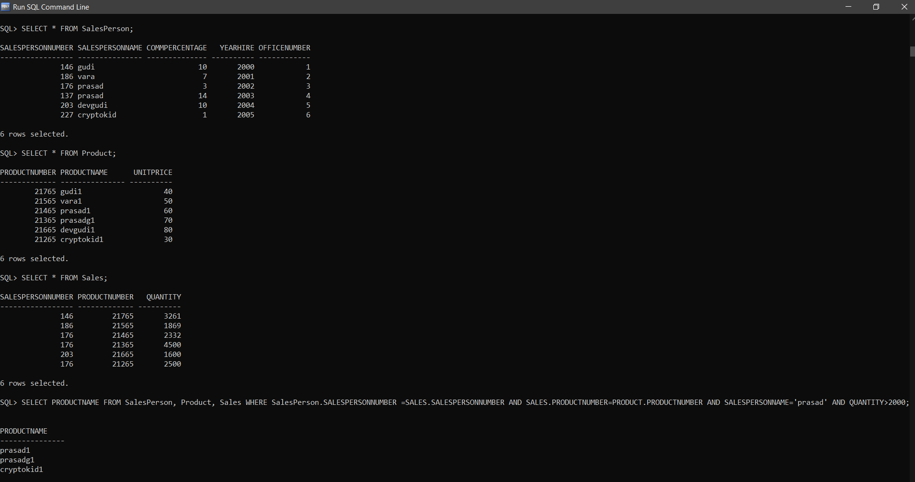

**20. Which salespersons with salesperson numbers greater than 200 have the lowest commission percentage? (We’ll identify salespersons by their salesperson number.)**

SELECT * FROM SalesPerson WHERE SALESPERSONNUMBER >200 AND COMMPERCENTAGE = (SELECT MIN(COMMPERCENTAGE) FROM SALESPERSON);



